SHRI GOVINDRAM SEKSARIA INSTITUTE OF TECHNOLOGY AND SCIENCE

Department of Computer Engineering

B.Tech Computer Science


Internship Report

3rd year (2020-2024)

Submitted By:
Divyansh Mathiya
0801CS213D02


1

INDEX

Title | Page No.
INTERNSHIP CERTIFICATE | 3
ORGANIZATION | 4
INFORMATION
INTERNSHIP SUMMARY | 5
INTERNSHIP DETAIL | 6
REPORT
LEARNING OUTCOME OF | 7
INTERNSHIP

2

INTERNSHIP CERTIFICATE

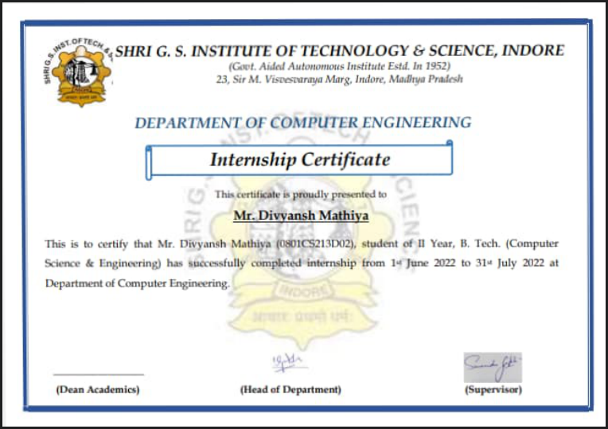

3

ORGANIZATION INFORMATION

Organization | Shri G.S Institute of Technology and Science
Address | 23 Sir M. Visvesvaraya Marg, Indore, Madhya
 | Pradesh
Title | Computer Science Department
Mode | offline
Stipend Received | 0
Duration | 2 months
Time From - To | 1 June 2022 – 31 July 2022

Company Name: Computer Science Department

4

INTERNSHIP SUMMARY

Title: Software Engineer Intern

Duration: 2 months

Nature of Work: Software Development

Technologies Used:

- Frontend – Swing

- Backend – Java

5

INTERNSHIP DETAIL REPORT

Project Title: Automation of Exam duty invigilation chart.

Month |  | Week | Task
June 2022 | • | Week 1 | • Configuring tools and setup environment for
 |  |  | development.
 | • | Week 2 | • Creating functions to accept and validate input files.
 | • | Week 3 | • Creating business objects and other functionalities.
 | • | Week 4 | • Converting business objects to business class.
July 2022 | • | Week 1 | • Designing algorithm and completing backend.
 | • | Week 2 | • Designing and creating frontend.
 | • | Week 3 | • Testing of the project.
 | • | Week 4 | • Creating reports and user manual for the software.

6

LEARNING OUTCOME OF INTERNSHIP

- Handling excel file using apache poi.

- Learning swing for frontend designing.

- Analysis in designing of algorithm.

- Learned Using Github (Version control system).

- Sticking to strict deadlines.

- Learned to work as a team.

- Develop communication, interpersonal and other critical skills.

- Develop work habits.

7

